A PROJECT REPORT
ON
S&T Supercars
SUBMITTED TO
RASHTRASANT TUKADOJI MAHARAJ NAGPUR UNIVERSITY, NAGPUR
IN PARTIAL FULFILLMENT OF THE REQUIREMENT
FOR THE AWARD OF THE DEGREE OF
BACHLOR OF COMMERCE (COMPUTER APPLICATION)

SUBMITTED BY:

MR. SAGAR V. NINAVE
MR. TUSHAR L. KATEWAR
MR. ANUP BAGHEL
GUIDED BY:

DR. PRASHANT P. YENDE
HEAD OF DEPARTMENT
COMPUTER APPLICATION DEPARTMENT
SHRI BINZANI CITY COLLEGE, NAGPUR
YEAR 2015-2016

CERTIFICATE

This to certify that the project entitled on “S&T SUPERCARS “submitted by
MR. SAGAR V. NINAVE, TUSHAR L. KATEWAR, ANUP BAGHEL As partial fulfillment for the Requirement of Bachelor of Commerce (computer application) of RASHTRASANT TUKDOJI MAHARAJ NAGPUR UNIVERSITY, NAGPUR for the academic session 2015-2016.

This work is carried by under my supervision and has guided and has undergone requisite
Of prescribed by university for project work.

Dr. Prashant P. Yende
(Project Guide)

(Internal Examiner) (External Examiner)
DATE:
PLACE:

DECLARATION

We hereby declare that the project entitled “S&T SUPERCARS”, has been completed by us in partial fulfillment of BACHELOR OF COMMERCE (COMPUTER APPLICATION) Degree examination as prescribed by Rashtrasant Tukdoji Maharaja Nagpur University, Nagpur and has not been submitted for any examination as not form a part of any other Course undergone by us.

MR. SAGAR V. NINAVE
MR. TUSHAR L. KATEWAR
MR. ANUP BAGHEL

PLACE: NAGPUR

DATE:

ACKNOWLEDGEMENT

The completion of project report on “S&T SUPERCARS”, has given us immense pleasure and knowledge. We are sincerely thankful to MR. Prasant P. Yende (Project Guide). MRS. Mona Chandak and MS. Pooja Jaiswal madam who have co-operated with us at different Stages during the preparation of the project. Our sincere thanks to all the staff of BCCA Department without whose help it would not have be possible for us to complete this report.

This work is virtually the result of inspiration gives by them. We would also like to thank all the library& non-teaching staffer their help and last but not least, we would like to thank all our friends and our entire family member for their constant help and support.

MR. SAGAR V. NINAVE
MR. TUSHAR L. KATEWAR
MR. ANUP BAGHEL

[B.COM (COMPUTER APPLICATION)-III]

INDEX
Particulars | Page No.
1) Introduction | 7
2) Objective | 8
3) Project Categories | 9
4) Front End & back End | 10-12
5) Tools/ Platforms | 13
6) Number Of Menus | 14-15
7) A Complete Coding of website  - Log In  - Sign Up  - Home Page  - About Page  - Services Page  - Gallery Page  - Contact Page  - Feedback Page | 16-18  19-23  24-32  33-39  40-52  53-58  59-65  66-73
9) Output
10) Conclusion
11) Future Development

BRIEF REVIEW
OF THE PROJECT

This project is aimed to develop a website which can be used to sale and manage information of luxury cars and super car. The entire project is being developed to solve all the problems faced inkeeping getting information about cars.
This project stores the information about all the types of cars. The Project provides the Information to the people after visiting this website.
This website provides the facility to view details of a car name, cost, performance, photos video etc.
INTRODUCTION

This project is aimed to develop a website which can be used to sale and manage information of luxury cars and super car. The entire project is being developed to solve all the problems faced in keeping getting information about cars.
This project stores the information about all the types of cars. The Project provides the Information to the people after visiting this website.
This website provides the facility to view details of a car name, cost, performance etc.

OBJECTIVES

Though this project has almost transactions on cars but the main objectives to be obtained are as follows:

- To provide information.

- To selling cars.

- To save time.

- To provide better service.

PROJECT CATEGORIES

- Operating System / Platform : WINDOWS-XP AND ABOVE
- Front End : Web Browser
- Back End : MS-ACCESS

FRONT-END AND BACK-END USED

FRONT END:-

WEB BROWSER

A browser is an application program that provides a way to look at and interact with all the information on the World Wide Web. The word "browser" seems to have originated prior to the Web as a generic term for user interfaces that let you browse (navigate through and read) text files online.

Technically, a Web browser is a client program that uses HTTP (Hypertext Transfer Protocol) to make requests of Web servers throughout the Internet on behalf of the browser user. Most browsers support e-mail and the File Transfer Protocol (FTP) but a Web browser is not required for those Internet protocols and more specialized client programs are more popular.

The first Web browser, called World Wide Web, was created in 1990. That browser's name was changed to Nexus to avoid confusion with the developing information space known as the World Wide Web. The first Web browser with a graphical user interface was Mosaic, which appeared in 1993. Many of the user interface features in Mosaic went into Netscape Navigator. Microsoft followed with its Internet Explorer (IE).

As of September 2006, Internet Explorer is the most commonly used browser, having won the so-called browser wars between IE and Netscape. Other browsers include:

- Firefox, which was developed from Mozilla (the open source version of Netscape).
- Flock, an open source browser based on Firefox and optimized for Web 2.0 features such as blogging and social bookmarking .
- Safari, a browser for Apple computers (at this writing, the third most popular browser).
- Lynx, a text-only browser for UNIX shell and VMS users.
- Opera, a fast and stable browser that's compatible with most relatively operating systems.

BACK-END:-
MICROSOFT ACCCESSs

1] What is database?

A database is a collection of the information that’s released to a particular
Subject or purpose, such as tracking customer order or maintain a music collection. If
Your database isn’t store on a computer or only parts of it are you may be tracking
Information from a variety of source that you have to go ordinate and organize
Yourself
Before beginning to use Microsoft access as backend, it is important to
Understand its capabilities and the type of task of design to perform Microsoft access 2007 is multiplies product whose use is bounded.
Access is a database management system (DBMS). Like other product in
this category, access storage and retries data present information and automates respective
task (such as maintain account payable, performing inventory control and scheduling) by
using data and run powerful reports.
Access is also powerful window application for the first time the predicative
of database management need the usability to Microsoft window, Because both window
and access are form Microsoft and both the product work very well together.

TOOLS & PLATFORM

Hardware Specification

- Processor : Intel Pentium
- RAM : Upto1 G.B.
- Hard Disk : Up to 40 GB

NUMBER OF MENU

Menus:

  - HOME:
When a user reach to website and after registered on website it will be get a first page which is home page.

  - ABOUT:
When user click on about menu it will get all information about companies such as History, Revenue, working Employees, headquarter etc.

  - SERVICE:

This menu provides information about services. When user clicks of services menu it will open a sub menu of that menu which contains following menu:

  - INSURANCE MAKING
After clicking on this sub menu it will get information about car insurance policy.

  - REPAIRING
After clicking on this sub menu it will get information about car repairing policy.

  - DEALING
After clicking on this sub menu it will get information about car dealing policy.

  - GALLERY:
When user needs to view photos or videos the he can click on gallery menu it will get two sub menus

  - PHOTOS
After clicking on this sub menu it will get images about car.

  - VIDEOS
After clicking on this sub menu it will get videos about car.

  - CONTACT:
When user needs to contact with the company and with its member he can click on contact menu it will get information about team

  - FEEDBACK:
When user needs to give feedback, suggestion or complain to the company then he can click on feedback menu it will get feedback form; after feeling a feedback form click on comment button.

COMPLETE CODING OF WEBSITE

- LOG IN PAGE CODING:-
<!DOCTYPE html>
<html lang="en">
<head>
<title>Log In-S&T Supercars</title>
<meta name="author"content="sagar"/>
<meta charset="UTF-8"/>
<style type="text/css">
*{margin:0; padding:0;}
#login{width:400px;margin:0auto;margin-top: 8px;margin-bottom:2%;transition:opacity 1s;-webkit-transition:opacity 1s;}
#triangle{width:0;border-top:12px solid transparent;border-right:12px solid transparent;margin:0 auto;}
#login h1{background:#3399cc;padding:20px 0;font-size:140%;font-weight:300;text-align:center;color:#ffffff;}
form{background:#f0f0f0;padding:6% 4%;}
input[type=text], input[type=password], input[type=number] { width: 100%;padding: 12px 20px;margin: 8px 0; box-sizing: border-box;}
html{background-image:url("background.jpg");}
header{background:none;}
h1{text-align:left;font-weight:bold;font-family:Pristina; color:#FFFFFF; font-size:50pt; }
p{color:#FFFFFF; font-family:Comic Sans MS; font-size:30px;}
</style>
</head>
<body>
<header>
<a href="logo.html"> <img src="logo.jpg" width=10% height=10% align="left"/> </a><br/>
<h1> <font color="red" face="Pristina"> S&T Supercars </h1>
</header>
<body>
<hr/> <h1>Welcome to <font color="red" face="Pristina"> S&T Supercars </font></h1>
<center><span href="#" class="button" id="toogle-login"> <a href="login.html"> Login</a></span>
<span href="#" class="button" id="toogle-login"> <a href="signup.html"> Sign Up </a></span>
<div id="login">
<div id="triangle"> </div>
<h1>Login</h1>
<form class="input">
<font face="Pristina" size="5"> Username &nbsp;&nbsp;&nbsp;&nbsp; <input type="text" placeholder="Enter Username" autofocus> <br/>
Password &nbsp&nbsp;&nbsp;&nbsp;&nbsp;&nbsp;<input type="password" placeholder="Enter Password">
<br> <br>
<center> <a href="home.html"> <img src="login.jpg" width=20% height=1% align="center" border=1> </a> </center>
</form>
</center>
</div>
<br/><br/>
<hr/>
</body>
<footer>
<p><u> <small> <small> OUR TEAM </small> </small> </u> <br/>
<small><small> Sagar Ninave </small> </small> <br/>
<small><small> Tushar Katewar</small> </small> <br/>
<small><small> Anup Baghel</small> </small> </p> </small>
<p id="copy"> <small> <small> &copy;Copy right reserved by <font color="red" face="Pristina"> S&T Supercars </font> </small> </small> </p>
</footer>
</body>
</html>

- SIGN UP PAGE CODING:-

<!DOCTYPE html>
<html lang="en">
<head>
<title>Sign Up-S&T Supercars</title>
<meta name="author"content="sagar"/>
<meta charset="UTF-8"/>
<style type="text/css">
<style>
form{background:#f0f0f0;padding:6% 4%;}
input[type=text], input[type=password], input[type=number]
{ width:100%;padding: 12px 20px;margin: 8px 0; box-sizing: border-box;}
html{background-image:url("background.jpg");}
header{background:none;}
h1{text-align:left;font-weight:bold;font-family:Pristina; color:#ffffff; font-size:50pt; }
p{color:#FFFFFF; font-family:Comic Sans MS; font-size:15px;}
</style>
</head>
<body>
<header>
<a href="logo.html"> <img src="logo.jpg" width=10% height=10% align="left"/> </a> <br/>
<h1><font color="red" face="Pristina"> S&T Supercars </font></h1>
</header>
<hr/> <h1>Welcome to <font color="red" face="Pristina"> S&T Supercars </font></h1>
<form method="post">
<table cellspadding="0" width="50%" align=right valign=top > <tr> <th align=left>
<h1 align=center> <b> <small><small><small> Create Your <font color="red"> S&T Supercars </font> Account </small> </small> </small> </b> </h1>
First Name <br>
<input type=text placeholder="First Name" autofocus/> <br>
Last Name<br>
<input type=text placeholder="Last Name" > <br>
Create a Password <br>
<input type="password" placeholder="New Password"> <br>
Confirm your Password <br>
<input type="password" placeholder="Repeat Password"> <br>
Birthday <br> <br>
<select>
<option> Jan </option> <option> Feb </option> <option> Mar </option>
<option> Apr </option> <option> May </option> <option> Jun </option>
<option> Jul </option> <option> Aug </option> <option> Sep </option>
<option> Oct </option> <option> Nov </option> <option> Dec </option>
</select>
<select>
<option> 01 </option> <option> 02 </option> <option> 03 </option> <option> 04 </option> <option> 05 </option> <option> 06 </option> <option> 07 </option> <option> 08 </option> <option> 09 </option> <option> 10 </option> <option> 11 </option> <option> 12 </option> <option> 13 </option> <option> 14</option> <option> 15 </option> <option> 16 </option> <option> 17 </option> <option> 18 </option> <option> 19 </option> <option> 20 </option> <option> 21 </option> <option> 22 </option> <option> 23 </option> <option> 24 </option> <option> 25 </option> <option> 26 </option> <option> 27 </option> <option> 28 </option> <option> 29 </option> <option> 30 </option> <option> 31</option>
</select>
<select>
<option> 1990 </option> <option> 1991 </option> <option> 1992 </option> <option> 1993 </option> <option> 1994 </option> <option> 1995</option> <option> 1996 </option> <option> 1997 </option> <option> 1998 </option> <option> 1999 </option> <option> 2000 </option> <option> 2001 </option> <option> 2002 </option> <option> 2003 </option> <option> 2004 </option> <option> 2005 </option> <option> 2006 </option> <option> 2007</option> <option> 2008 </option> <option> 2009 </option> <option> 2010 </option> <option> 2011 </option> <option> 2012 </option> <option> 2013 </option> <option> 2014 </option> <option> 2015 </option> <option> 2016 </option> <option> 2017 </option> <option> 2018 </option><option> 2019 </option> <option> 2020 </option>
</select> <br> <br>
Gender <br> <br>
<input type=radio name=gender value=male>Male <br>
<input type=radio name=gender value=female>female<br>
Mobile Phone <br>
<input type=text placeholder="Mobile"> <br>
Your current email address <br>
<input type=text placeholder="Current Email"> <br>
<b> Default homepage </b> <br>
<input type=checkbox name=text value=text> Set <font color="red" face="Pristina"> S&T Supercars </font> as my default homepage.<br>
<p align=left> <font color=gray> <samll> Your default homepage in your browser is the <br> first page that appears when you open your browser. </font> </samll> </p>
<input type=checkbox name=text value=text> Skip this verification <br> (phone verification may be required) <br>
Location <br>
<select>
<option> India </option> <option> UK </option> <option> USA </option> <option> Brazil </option> <option> Austrelia </option> <option> South Africa </option> <option> Maleshiya </option> <option> Singapur </option> <option> Pakistan </option> <option> Nepal </option> <option> China </option> <option> Japan </option>
</select> <br> <br>
<input type=checkbox name=text value=text> I agree to the <font color="red" face="Pristina"> S&T Supercars </font>Terms of <br> Service and Privacy Policy <br> <br>
<a href="done.html"> <img src="signup.jpg" alt="signup.jpg" border=2 bordercolor=red height=30 width=70 > </a> <br>

</th>
</tr>
</table>
</form>
<br/><br/><br/><br/><br/><br/><br/><br/><br/><br/><br/><br/><br/><br/>
<br/><br/><br/><br/><br/><br/><br/><br/><br/><br/><br/><br/><br/><br/>
<br/><br/><br/><br/><br/><br/><br/><br/><br/><br/><br/><br/><br/><br/>
<br/><br/><br/><br/><br/><br/><br/><br/><br/><br/><br/><br/><br/><br/>
<br/><br/><br/><br/><br/><br/><br/><br/>
<hr/>
<footer>
<p><u> <small> OUR TEAM </small></u> <br/>
<small> Sagar Ninave </small> <br/>
<small> Tushar Katewar </small> <br/>
<small> Anup Baghel</p> </small>
<p id="copy"> <small> &copy;Copyright reserved by<font color="red" face="Pristina"> S&T Supercars </font> </small> </p>
</footer>
</body>
</html>

3) HOME PAGE CODING :-
<!DOCTYPE html>
<html lang="en">
<head>
<title>HOME-S&T Supercars</title>
<meta name="author"content="sagar"/>
<meta charset="UTF-8"/>
<style type="text/css">
html{background-image:url("background.jpg");}
header{background:none;}
h1{text-align:left;font-weight:bold;font-family:Pristina; color:red; font-size:50pt;}
h2{text-align:left;font-weight:bold;font-family:Pristina; color:#FFFFFF; font-size:30pt;}
p{text-align:left;font-weight:bold;font-family:arial; color:#FFFFFF; font-size:20pt;}
h3{color:#000000; background-color:orange; font-family:arial black; font-size:15px;}
#menu{width:100%; height:50px; margin:0; z-index:99; position:relative; background-color:none; }
.navbar{height:50px; padding:0; margin:0; position:absolute; border-right:none;}
.navbar li{height:auto; width:150px;float:left;text-align:center;list-style:none;font:normal bold12px/1.2em Arial,Verdana,Helvetica;padding:0;margin:0;background-color:none;}
navbar a{padding:18px 0;border-left:none;border-right:none;text-decoration:none;color:#FFFFFF;display:block;font-family:'Comic Sans MS';}
.navbar li:hover, a:hover{background-color:#009999;color:#FFFFFF;}
.navbar li ul{display:none;height:auto; margin:0;padding:0;}
.navbar li:hover ul{display:block;}
.navbar li ul li{background-color:#5EAE9E;}
.navbar li ul li a{border-left:none;border-right:none;border-top:1px solid #FFFFFF;border-bottom:none;}
.navbar li ul li a:hover{background-color:none;}
a:link{color:white; background:none; text-decoration:none;}
a:hover{color:orange; background:none;}
div.transbox{margin:10px;background-color:#c6dbf4;border:1px solid black;opacity:1;
filter:alpha(opacity=60);padding:0px}
div.transbox p{margin:5px;padding:5px;font:weight:bold;color:red;}
</style>
</head>
<body>
<header>
<a href="logo.html"> <img src="logo.jpg" width=10% height=10% align="left"/> </a> <br/>
<h1> S&T Supercars </h1>
<div id="menu">
<ul class="navbar">
<li><a href="home.html"><strong>HOME</strong></a></li>
<li><a href="about.html"><strong>ABOUT</strong></a><li>
<li><a href="#"><strong>SERVICES</strong></a>
<ul>
<li><a href="insurancemaking.html"><strong>Insurance Making</strong></a></li>
<li><a href="repairing.html"><strong>Repairing</strong></a></li>
<li><a href="dealing.html"><strong>Dealing</strong></a></li>
</ul>
</li>
<li><a href="#"><strong>GALLERY</strong></a>
<ul>
<li><a href="photo.html"><strong>Photos</strong></a></li>
<li><a href="video.html"><strong>Videos</strong></a></li>
</ul>
</li>
<li><a href="contact.html"><strong>CONTACT</strong></a></li>
<li><a href="feedback.html"><strong>FEEDBACK</strong></a></li>
</ul>
</div>
</header>
<hr/>
<body>
<table width=5%; height=20% align=left>
<tr align="center" align=left valign=Middle>
<th rowspan=9 align="left"; valign="Middle">
<ul>
<li> <font color="red" face="Pristina" size=5> S&T Supercars </font> <br> <br>
<ul>
<li> <font color="white" face="arial" size=3> Luxery Cars </font> <br> <br>
<ul>
<li> <a href="home.html"> Mercedes </font> </a> </li>
<li> <a href="audi.html"> Audi </font </a> </li>
<li> <a href="jaguar.html"> Jaguar </font </a> </li>
<li> <a href="bmw.html"> BMW </font </a> </li>
<li> <a href="rollsroyce.html"> Rolls Royes </font </a> </li><br>
</ul>
</li>
<ul>
</ul>
<li> <font color="white" face="arial" size=3> Super Cars </font> <br> <br>
<ul>
<li> <a href="lamborghini.html"> Lamborghini </font> </a> </li>
<li> <a href="ferrari.html"> Ferrari </font> </a> </li>
<li> <a href="porsche.html"> Porsche </font> </a> </li>
<li> <a href="pagani.html"> Pagani </font> </a> </li>
<li> <a href="astonMartin.html"> Aston Martin </font> </a> </li>
</ul>
</li>
</ul>
</li>
</ul>
</th>

</tr>
</table>
<table width=60%; height=50% align=center>
<tr>
<th>
<div class="transbox">
<h3> Mercedes-Benz F125 B Class </h3>
<img src="mercedes1.jpg" width="70%" height="100%" border=2 hspace=1 vspace=1 border=1> <br>
<a href="purchase request.html"> <img src="purchase request.jpg" alt="purchase request" height=30 width=100 border=1> </a> <br>
<a href="http://www.carwale.com/mercedesbenz-cars/b-class/" target="blank"> <img src="view page.jpg" alt=view page height=30 width=100> </a> <br>
</div>
</th>
<th>
<div class="transbox">
<h3> Mercedes-AMG GT</h3>
<img src="mercedes2.jpg" width="70%" height="100%" border=2 hspace=1 vspace=1 border=1> <br> <br>
<a href="purchase request.html"> <img src="purchase request.jpg" alt="purchase request" height=30 width=100 border=1> </a> <br>
<a href="http://mercedes-amg-gt.mercedes-benz.com/en_COM"> <img src="view page.jpg" alt=view page height=30 width=100> </a> <br>
</div>
</th>
</tr>
<tr>
<th>
<div class="transbox">
<h3> Mercedes-AMG GT </h3>
<img src="mercedes3.jpg" width="70%" height="100%" border=2 hspace=1 vspace=1 border=1> <br>
<a href="purchase request.html"> <img src="purchase request.jpg" alt="purchase request" height=30 width=100 border=1> </a> <br>
<a href="http://www.mercedes-benz.ca/content/canada/mpc/mpc_canada_website/en/home_mpc/passengercars.html"> <img src="view page.jpg" alt=view page height=30 width=100> </a> <br>
</div>
</th>
<th>
<div class="transbox">
<h3> Mercedes GLA Compac</h3>
<img src="mercedes4.jpg" width="70%" height="100%" border=2 hspace=1 vspace=1 border=1> <br>
<a href="purchase request.html"> <img src="purchase request.jpg" alt="purchase request" height=30 width=100 border=1> </a> <br>
<a href="http://www.mercedes-benz.ie/content/ireland/mpc/mpc_ireland_website/enng/home_mpc/passengercars/home/world/news_and_events/ireland_-_local_events/NGCC_Range.html"> <img src="view page.jpg" alt=view page height=30 width=100> </a> <br>
</div>
</th>
</tr>
<tr>
<th>
<div class="transbox">
<h3> Mercedes CLS63 AMG </h3>
<img src="mercedes5.jpg" width="70%" height="100%" border=2 hspace=1 vspace=1 border=1> <br>
<a href="purchase request.html"> <img src="purchase request.jpg" alt="purchase request" height=30 width=100 border=1> </a> <br>
<a href="http://gearheads.org/2015-mercedes-benz-cls-class-gets-a-new-look/"> <img src="view page.jpg" alt=view page height=30 width=100> </a> <br>
</div>
</th>
<th>
<div class="transbox">
<h3> Mercedes C-Class </h3>
<img src="mercedes6.jpg" width="70%" height="100%" border=2 hspace=1 vspace=1 border=1> <br> <br>
<a href="purchase request.html"> <img src="purchase request.jpg" alt="purchase request" height=30 width=100 border=1> </a> <br>
<a href="http://www.mbusa.com/mercedes/index"> <img src="view page.jpg" alt=view page height=30 width=100></a> <br>
</div>
</th>
</tr>
<tr>
<th>
<div class="transbox">
<h3> Mercedes-Ben GLT-Class</h3>
<img src="mercedes7.jpg" width="70%" height="100%" border=2 hspace=1 vspace=1 border=1> <br>
<a href="purchase request.html"> <img src="purchase request.jpg" alt="purchase request" height=30 width=100 border=1> </a> <br>
<a href="http://www.digitaltrends.com/cars/2019-mercedes-benz-glt-news-specs-rumors/"> <img src="view page.jpg" alt=view page height=30 width=100> </a> <br>
</div>
</th>
<th>
<div class="transbox">
<h3> Mercedes-AMG GT S </h3>
<img src="mercedes8.jpg" width="70%" height="100%" border=2 hspace=1 vspace=1 border=1> <br> <br>
<a href="purchase request.html"> <img src="purchase request.jpg" alt="purchase request" height=30 width=100 border=1> </a> <br>
<a href="http://www.carscoops.com/2015/12/white-mercedes-amg-gt-s-sits-on-pur.html"> <img src="view page.jpg" alt=view page height=30 width=100> </a> <br> <br>
</div>
</th>
</tr>
</table>
<table align=center>
<tr>
<th>
&nbsp;&nbsp;&nbsp;&nbsp;&nbsp;&nbsp;&nbsp;&nbsp;&nbsp;&nbsp;&nbsp;&nbsp;&nbsp;&nbsp;&nbsp;&nbsp;&nbsp;&nbsp;&nbsp;&nbsp;&nbsp;&nbsp;&nbsp;&nbsp;&nbsp;&nbsp;&nbsp;&nbsp;&nbsp;&nbsp;&nbsp;&nbsp;&nbsp;&nbsp;&nbsp;&nbsp;&nbsp;&nbsp;&nbsp;&nbsp;&nbsp;&nbsp;&nbsp;&nbsp;&nbsp;&nbsp;&nbsp;&nbsp;&nbsp;&nbsp;&nbsp;&nbsp;&nbsp;&nbsp;&nbsp;&nbsp;&nbsp;&nbsp;&nbsp;&nbsp;&nbsp;
<a href="home.html"> <img src="previous.jpg" alt="previous" height=30 width=80> </a>
</th>
<th>
&nbsp;&nbsp;&nbsp;&nbsp;&nbsp;&nbsp;&nbsp;&nbsp;&nbsp;&nbsp;&nbsp;&nbsp;&nbsp;&nbsp;&nbsp;&nbsp;&nbsp;&nbsp;&nbsp;&nbsp;&nbsp;&nbsp;&nbsp;&nbsp;&nbsp;&nbsp;&nbsp;&nbsp;&nbsp;&nbsp;&nbsp;&nbsp;&nbsp;&nbsp;&nbsp;&nbsp;&nbsp;&nbsp;&nbsp;&nbsp;&nbsp;&nbsp;&nbsp;&nbsp;&nbsp;&nbsp;&nbsp;&nbsp;&nbsp;&nbsp;&nbsp;&nbsp;
<a href="audi.html"> <img src="next.jpg" alt="next" height=30 width=80> </a>
</th>
</tr>
</table>
<br/><br/>
<body>
<hr/>
<footer>
<big> <p><u> <small> OUR TEAM </small> </u> <br/>
<small><small> Sagar Ninave </small> </small> <br/>
<small><small> Tushar Katewar </small> </small> <br/>
<small> <small>Anup Baghel</p> </big> </small></small>
<a href="login.html"> Log Out </a>

<p id="copy"> <small> <small> &copy;Copyright reserved by<font color="red" face="Pristina"> S&T Supercars </font> </small> </small> </p>
</footer>
</body>
</html>

3) ABOUT PAGE CODING:

<!DOCTYPE html>
<html lang="en">
<head>
<title>About-S&T Supercars</title>
<meta name="author"content="sagar"/>
<meta charset="UTF-8"/>
<style type="text/css">
html{background-image:url("background.jpg");}
header{background:none;}
h1{text-align:left;font-weight:bold;font-family:Pristina; color:red; font-size:50pt;}
h2{text-align:left;font-weight:bold;font-family:Pristina; color:#01a2d7; font-size:30pt;}
h3{text-align:left;font-weight:bold;font-family:Pristina; color:#01a2d7; font-size:20pt;}
p{color:#FFFFFF; font-family:Comic Sans MS; font-size:30px;}
#menu{width:100%; height:50px; margin:0; z-index:99; position:relative; background-color:none; }
.navbar{height:50px; padding:0; margin:0; position:absolute; border-right:none;}
.navbar li{height:auto; width:150px;float:left;text-align:center;list-style:none;font:normalbold12px/1.2emArial,Verdana,Helvetica;padding:0;margin:0;background-color:none;}
.navbar a{padding:18px 0;border-left:none;border-right:none;text-decoration:none;color:#FFFFFF;display:block;font-family:'Comic Sans MS';}
.navbar li:hover, a:hover{background-color:#009999;color:#FFFFFF;}
.navbar li ul{display:none;height:auto;margin:0;padding:0;}
.navbar li:hover ul{display:block;}
.navbar li ul li{background-color:#5EAE9E;}
.navbar li ul li a{border-left:none;border-right:none;border-top:1px solid #FFFFFF;border-bottom:none;}
.navbar li ul li a:hover{background-color:none;}
a:link{color:white; background:none;background:none;text-decoration:none;}
a:hover{color:orange; background:none;}
div.transbox{margin:30px;background-color:#ffffff;border:1px solid black;opacity:0.7;filter:alpha(opacity=60);padding:5px}
div.transbox p{margin:10px;padding:10px;font:weight:bold;color:#01a2d7;font-size:20px;}
</style>
</head>
<body>
<header>
<a href="logo.html"> <img src="logo.jpg" width=10% height=10% align="left"/> </a> <br/>
<h1> S&T Supercars </h1>
<div id="menu">
<ul class="navbar">
<li><a href="home.html"><strong>HOME</strong></a></li>
<li><a href="about.html"><strong>ABOUT</strong></a><li>
<li><a href="#"><strong>SERVICES</strong></a>
<ul>
<li><a href="insurancemaking.html"><strong>Insurance Making</strong></a></li>
<li><a href="repairing.html"><strong>Repairing</strong></a></li>
<li><a href="dealing.html"><strong>Dealing</strong></a></li>
</ul>
</li>
<li><a href="#"><strong>GALLERY</strong></a>
<ul>
<li><a href="photo.html"><strong>Photos</strong></a></li>
<li><a href="video.html"><strong>Videos</strong></a></li>
</ul>
</li>
<li><a href="contact.html"><strong>CONTACT</strong></a></li>
<li><a href="feedback.html"><strong>FEEDBACK</strong></a></li>
</ul>
</div>
</header>
<hr/>
<fieldset>
<legend> <h2> <font color="#ffffff">Welcome to </font> <font color="red" face="Pristina"> S&T Supercars </font> </h2> </legend>
<table border=1>
<tr>
<th> <h2> Headquarter </h2>
<img src="college.jpg" style="border:1px solid white; height:100%; width:100%; margin=0px; align:top; ">
<div class="transbox">
<p > <h3> Information </font> </h3>
<font color="red" face="Pristina" size=10> S&T Supercars </font>
provides information about cars and provides service such as Purchasing, Insurance Making, Repairing and Dealing etc. headquartered Nagpur, Maharashtra India.Its website was launched on February 14, 2010, by <font color="red" face="Pristina" size=5>
Sagar Ninave </font> with his S.B.City College Friend and fellow students <font color="red" face="Pristina" size=5> Tushar Katewar, Anup Baghel, Nikilesh Rahise, Hitanshu Ikhar, Ashish Kale, Shivshankar Gurpude, </font> The founders had initially limited the website's membership to Indian People, but later expanded it world wide. anyone who is at least 13 years old was allowed to become a registered user of the website, though the age requirement may be higher depending on applicable local laws. Its name comes from the Sagar & Tushar often given to RTM university students.
<br> <br>
<h3> History </font> </h3>
After registering to use the site, users can send purchase request to the company, use policies Which is made for costumer such as insurance making, dealing, repairing and receive notifications when others update their profiles. Additionally, users may join common-interest user groups, organized by workplace, over 1.18 billion monthly users as of August 2015.<font color="red" face="Pristina" size=5> S&T Supercars </font> has come under scrutiny for their privacy policies.<font color="red" face="Pristina" size=5> S&T Supercars </font> , Inc. held its initial public offering in February 2012 and began selling stock to the public three months later, reaching an original peak market capitalization of $104 billion. On July 13, 2015, <font color="red" face="Pristina" size=5> S&T Supercars </font> became the fastest company in the Standard & Poor's 500 Index to reach a market cap of $250 billion. Following its Q3 earnings call in 2015, <font color="red" face="Pristina" size=5> S&T Supercars's </font> market cap soared past $300 billion.
<br> <br>
<h3> Revenue </font> </h3>
Most of <font color="red" face="Pristina" size=5> S&T Supercars's </font> revenue comes from advertising. <font color="red" face="Pristina" size=5> S&T Supercars </font>generally has a lower clickthrough rate (CTR) for advertisements than most major Web sites. According to BusinessWeek.com, banner advertisements on <font color="red" face="Pristina" size=5> S&T Supercars </font> have generally received one-fifth the number of clicks compared to those on the Web as a whole, although specific comparisons can reveal a much larger disparity. For example, while Google users click on the first advertisement for search results an average of 8% of the time (80,000 clicks for every one million searches),<font color="red" face="Pristina" size=5> S&T Supercars's </font> users click on advertisements an average of 0.04% of the time (400 clicks for every one million pages).
Sarah Smith, who was <font color="red" face="Pristina" size=5> S&T Supercars's </font>Online Sales Operations Manager until 2012, reported that successful advertising campaigns on the site can have clickthrough rates as low as 0.05% to 0.04%, and that CTR for ads tend to fall within two weeks.
The cause of Facebook's low CTR has been attributed to younger users enabling ad blocking software and their adeptness at ignoring advertising messages, as well as the site's primary purpose being social communication rather than content viewing. According to digital consultancy iStrategy Labs in mid-January 2014, three million fewer users aged between 13 and 17 years were present on <font color="red" face="Pristina" size=5> S&T Supercars's </font> Social Advertising platform compared to 2011. However, Time Writer and Reporter Christopher Matthews stated in the wake of the iStrategy Labs results:
</p>
</div>
<th>
<p> <font face=arial; size=2; color=white>
<h3> <font face=Pristina align=left color=#01a2d7 size=10pt> Type </font> </h3> Public <br> <hr>
<h3> Traded As </h3> BSE <br> <hr>
<h3> Founded </h3> 1Apr 2015 <br> <hr>
<h3> Headquarter </h3> Nagpur, Mharashra, India <br> <hr>
<h3> Area Served </h3> World Wide <br> <hr>
<h3> Chairman, CEO </h3> Sagar Ninave <br> <hr>
<h3> Founder </h3> Sagar Ninave <br> Tushar Katewar <br> Anup Baghel<hr>
<h3> Revenue </h3> $1.3 billion <br> <hr>
<h3> Industry </h3> Commercial <br> <hr>
<h3> Revenue </h3> $1.3 billion <br> <hr>
<h3> Employees </h3> 1200 <br> <hr>
<h3> Ragistration </h3> Required <br> <hr>
<h3> Website </h3> www.s&tsupercars.com <br> </font>
</p>
</th>
</tr>
</table> <br> <br><br>
<p align=right> Thanking For Visit....!</p>
<br/><br/> </fieldset>
<br><br>
<hr/>
<footer>
<p><u> <small> <small> OUR TEAM </small> </small> </u> <br/>
<small><small> Sagar Ninave </small> </small> <br/>
<small><small> Tushar Katewar</small> </small> <br/>
<small><small> Anup Baghel</small> </small> </p> </small>
<p> <small> <small> &copy;Copy right reserved by <font color="red" face="Pristina"> S&T Supercars </font> </small> </small> </p>
</footer>
</body>
</html>

4) SERVICE – INSURANCE MAKING PAGE CODING:

<!DOCTYPE html>
<html lang="en">
<head>
<title>About-S&T Supercars</title>
<meta name="author"content="sagar"/>
<meta charset="UTF-8"/>
<style type="text/css">
html{background-image:url("background.jpg");}
header{background:none;}
h1{text-align:left;font-weight:bold;font-family:Pristina; color:red; font-size:50pt;}
h2{text-align:left;font-weight:bold;font-family:Pristina; color:#01a2d7; font-size:20pt;}
h3{text-align:left;font-weight:bold;font-family:Pristina; color:red; font-size:20pt;}
h4{text-align:center;font-weight:bold;font-family:Pristina; color:red; font-size:20pt;}
p{color:#FFFFFF; font-family:Comic Sans MS; font-size:30px;}
#menu{width:100%; height:50px; margin:0; z-index:99; position:relative; background-color:none; }
.navbar{height:50px; padding:0; margin:0; position:absolute; border-right:none; }
.navbar li{height:auto; width:150px;float:left;text-align:center;list-style:none;font:normal bold 12px/1.2em Arial,Verdana,Helvetica;padding:0;margin:0;background-color:none;}
.navbar a{padding:18px 0;border-left:none;border-right:none;text-decoration:none;color:#FFFFFF;display:block;font-family:'Comic Sans MS';}
.navbar li:hover, a:hover{background-color:#009999;color:#FFFFFF;
.navbar li ul{display:none;height:auto;margin:0;padding:0;}
.navbar li:hover ul{display:block;}
.navbar li ul li{background-color:#5EAE9E;}
.navbar li ul li a{border-left:none;border-right:none;border-top:1px solid #FFFFFF;border-bottom:none;}
.navbar li ul li a:hover{background-color:none;}
a:link{color:white; background:none;background:none;text-decoration:none;}
a:hover{color:orange; background:none;}
div.transbox{margin:30px;background-color:#ffffff;border:1px solid black;opacity:0.7;filter:alpha(opacity=60);padding:5px}
div.transbox p{margin:10px;padding:10px;font:weight:bold;color:#01a2d7;fontsize:20px;}
form{ background-color:white;background-repeat:no-repeatpadding:100% 10%;opacity:0.6;margin=100%;}
input[type=text], input[type=password], input[type=number] { width:70%; padding: 12px 20px;margin: 8px 0; box-sizing: border-box;}
</style>
</head>
<body>
<header>
<a href="logo.html"> <img src="logo.jpg" width=10% height=10% align="left"/> </a> <br/>
<h1> S&T Supercars </h1>
<div id="menu">
<ul class="navbar">
<li><a href="home.html"><strong>HOME</strong></a></li>
<li><a href="about.html"><strong>ABOUT</strong></a><li>
<li><a href="#"><strong>SERVICES</strong></a>
<ul>
<li><a href="insurancemaking.html"><strong>Insurance Making</strong></a></li>
<li><a href="repairing.html"><strong>Repairing</strong></a></li>
<li><a href="dealing.html"><strong>Dealing</strong></a></li>
</ul>
</li>
<li><a href="#"><strong>GALLERY</strong></a>
<ul>
<li><a href="photo.html"><strong>Photos</strong></a></li>
<li><a href="video.html"><strong>Videos</strong></a></li>
</ul>
</li>
<li><a href="contact.html"><strong>CONTACT</strong></a></li>
<li><a href="feedback.html"><strong>FEEDBACK</strong></a></li>
</ul>
</div>
</header>
<hr/>
<fieldset>

<legend> <h2> Insuranace Policy </h2> </legend>
<div class="transbox">
<p >
<h3> Car Insurance </h3>
1) Car insurance is mandatory so choose a plan wisely. <br>
2) You can now save money, get discounts and find the best deal through PolicyBazaar. <br>
3) Compare various plans and buy hassle-free.<br><br>
Get best plans from top Insurance providers Lowest premium guaranteed Compare and buy instantly
Car Insurance or motor insurance covers for losses that you might incur if your car gets damaged or stolen.
The premium amount of your car insurance is decided on the basis of Insured Declared Value or IDV of the vehicle.
If you increase the IDV, the premium rises and if you lower it, the premium reduces. It is important for any policyholder
to compare various auto insurance options before going for a car insurance renewal or buying a new policy. <br>
<h3> Key Benefits of Car Insurance </h3>

1) Coverage against loss or damage to the insured vehicle.<br>
2) Coverage against loss or damage to your vehicle caused by accident, theft, fire, explosion, self ignition, lightning, riots,
strikes or act of terrorism, natural calamities.<br>
3) Coverage against financial liability caused by injury/death of a third party or damage to the property. <br>
Personal accident cover.
<h3> Why is it necessary to compare car insurance policies? </h3>
It is necessary to compare the car insurance policies as it can save a substantial amount of money and give you better
coverage options. However, comparing the policies manually can be a daunting task. Policy Bazaar makes it fairly easy for you.
When you compare quotes here you can save upto 55% on car insurance premiums along with getting add-ons like riders and
benefits on your plan. Make an informed purchase. Compare online and know your car insurance plan properly before buying. <br>
<h3> Coverage under Car Insurance </h3>
There are primarily 3 types of car insurance -
<h2> Third Party Liability Coverage </h2>
Third Party car insurance provides cover against any legal liability to a third party caused when you are at-fault driver.
It covers damage/injury caused by you to another person/property. A Third Party Liability cover is legally mandatory in India
under the Motor Vehicles Act.
<h2> Collision Coverage </h2>
Collision coverage protects the insured financially against damage of their own car. It pays the insured for damage caused by
collision which is usually an accident. Damage or loss due to theft or vandalism is not included in collision coverage.
<h2> Comprehensive Coverage </h2>
A comprehensive coverage is extensive and includes damage of car, theft of vehicle, third party legal liability and
personal accident cover. The policy coverage can be further extended by opting for add-ons like accessories cover, engine
protector, zero depreciation cover, medical expenses, etc. This type of coverage is the most popular as it offers end-to-end
coverage and thus less stress for the policyholder
<h3> No Claim Bonus </h3>
For every claim free year, the insured is rewarded with discount on the renewal premium. This discount is called -
No Claim Bonus (NCB). It is cumulative and increases every year. It usually ranges from 10% to 50% and can save
a substantial amount of money on your premium. <br><br>
<h3> What is not covered in Car Insurance? </h3>
Following features are usually not covered in car insurance: <br>
<ul>
<li> Loss or damage if a policy is not in force. </li>
<li> Gradual wear and tear of car and its parts. </li>
<li> Loss or damage to vehicle when driven by person without a valid driving license. </li>
<li> Loss or damage to vehicle as a result of intoxication due to drugs, alcohol etc.</li>
<li> Loss or damage to engine as a result of oil leakage.</li>
<li> Loss or damage to vehicle as a result of abuse of car manufacturer's guidelines.</li>
</ul>
<h3> Eligibility/Documentation Required for Car Insurance </h3>
Getting a car insured requires minimal documentation. For a new policy, you must submit the filled up
proposal form and copy of the Registration Certificate (RC). For renewals, you will need copy of the RC
(Registration Certificate) along with the copy of previous insurance policy.
Carefully fill in your complete details. This is an important step and will save you a lot of hassle during claim time.
<h3> How to Compare Online on PolicyBazaar? </h3>
On PolicyBazaar you have to fill a few simple details like make of the car, model, variant, year of manufacture, etc. You will then get quotes from various insurance providers. To get better discounts you must fill the form carefully. This way you will get customized quotes, one which saves money (upto 55%) on premiums and is also the best fit as per your needs.
You must be familiar with the following terms while filling the form:
Car Make, Model and Variant
This information is critical to calculate base premium. Luxurious, powerful and expensive car will attract more premiums. For e.g. a SUV car will always have a higher premium than a family car.
Year of Manufacture
The manufacture year of your car lets the insurance company assess its Insured Declared Value (IDV) that facilitates the underwriter to decide the annual premium for your car.
CNG Fitted Car
Being more vulnerable to combustion, a CNG fitted car is usually insured at a slightly higher premium than a plain petrol/diesel car.
Additional Covers
You need to mention whether you do or do not want to get a cover on electrical and non-electrical accessories fitted in your car. Most insurers provide a cover for your car accessories at an additional premium of 4% on its value.
<h3> Process Steps for Acquiring a New Four Wheeler Insurance Policy:</h3>
<ol type=1>
<li> Log in to www.policybazaar.com and click on the product icon.
</li> <li> If you want a fresh comparison of four wheeler insurance plans, click on 'Begin your comparison'. In case you have searched before, you can retrieve your previous searches and continue from where you left off by clicking on 'Get previous searches'.
</li> <li> Before you start the comparison, keep a few details handy such as the city of your car's registration, make and model, fuel type, and the car's variant.
</li> <li> To get new insurance quotes, key in all the above-mentioned details in the form and click on the 'Next' button.
</li> <li> On the next page, fill in your personal information such as your full name, email address, and mobile number. Click on 'View Quotes' to proceed.
</li> <li> In the quotes section, you'll have a list of different auto insurers with discounted price, add-ons, and final price. You can view each plan details and compare it with other plans well.
</li> <li> To get a discount on the premium, click on the 'Get Discount' button on the left side of the page. After clicking the button, a form will appear where you have to fill in your details. After completing the form, click on 'Apply Discount'.
</li> <li> Click on 'Select add-ons' to tick the list of added extras in your car such as 24*7 roadside assistance, No claim Bonus (NCB) protector, engine protector, key and lock replacement, and consumables.</li>
</li> <li> If you want to include passengers under the plan, click on 'Passenger/driver cover'.</li>
<li> To find the nearby motor garage, click on the 'Garage locator' on the bottom left of the page.
Fill in these details carefully then sit back and relax for a while. You will be presented with a list of insurance plans that suits your requirement at best possible rates. </li>
</ol>
<h3>
Get Discounts, Save Money, Buy Smart </h3>
A smart customer is in a constant hunt for discounts which will reduce the burden on his pocket. If you are one among
them then here are a few tips that will help you get discount and save money on premium value of your car insurance.
<h3> Voluntary Access </h3>
Voluntary deductible is the minimum amount that you declare to bear at the time of claim. The higher deductible you opt for, the lower will be your premium. Simply put it means that the financial burden on the insurance provider is less and you will also chip in when an accident or car damage happens
<h3> Anti-theft Discount </h3>
In case your car is fitted with an ARAI approved anti theft device, your insurer will offer additional discount (2.5% on the OD Premium). This discount is provided for the simple reason that an anti-theft device will make your car less liable to theft.
<h3> Privilege Membership </h3>
Members of the Automobile Association and some Professionals (Defense Personnel, Doctors and Govt. Employees) are entitled to get additional discount on their premium. So, never miss out to mention the same while searching for a quote.
While getting quotes for your vehicle at Policy Bazaar, you might see for yourself how changing even minor details make a huge difference to the final calculated premium. For example, take the case of Dr. Gupta. He's a doctor by profession and needs car insurance for his brand new Renault Duster. His car is fitted with an ARAI approved anti-theft kit. While getting a car insurance quote, he neither mentions his profession nor the fact that his car is fitted with an anti-theft kit. Thus he ends up paying a higher premium. On the contrary, if he did mention about these then, needless to say, his premium could have been lower by 25%.
Always fill in your correct and complete details while getting comparative Quotes from Policy Bazaar.
Buy and compare car insurance quotes online easily here at PolicyBazaar. Whether you want to buy a new policy for your car or renew your policy, get it right here in a few clicks.
</p>
<form method="post">
<table cellspadding=0 cellspacing=0 width="50%" align=center BORDER=2>
<tr>
<th align=left>
<h4> Make Insurance For Your Car </h4>
&nbsp;&nbsp;&nbsp;&nbsp;&nbsp; First Name <br>

&nbsp;&nbsp;&nbsp;&nbsp;&nbsp; <input type=text placeholder="First Name"autofocus/> <br>
&nbsp;&nbsp;&nbsp;&nbsp;&nbsp; Last Name <br>
&nbsp;&nbsp;&nbsp;&nbsp;&nbsp; <input type=text placeholder="Last Name" > <br>
&nbsp;&nbsp;&nbsp;&nbsp;&nbsp; E-Mail <br>
&nbsp;&nbsp;&nbsp;&nbsp;&nbsp; <input type="text" placeholder="Enter Your E-Mail"> <br>
&nbsp;&nbsp;&nbsp;&nbsp;&nbsp; Choose Your Car <br> <br>
&nbsp;&nbsp;&nbsp;&nbsp;&nbsp;
<select>
<option> Select </option><option> Mercedes </option> <option> Audi </option> <option> Jaguar </option> <option> Rolls Royce </option> <option> BMW </option> <option> Lamborghini </option> <option> Ferrari </option> <option> Porsche </option <option> Aston Martin </option> <option> Pagani </option>
</select> <br> <br>
&nbsp;&nbsp;&nbsp;&nbsp;&nbsp; <input type=number placeholder="Mobile"> <br>
&nbsp;&nbsp;&nbsp;&nbsp;&nbsp; Address <br> <br>
&nbsp;&nbsp;&nbsp;&nbsp;&nbsp; <textarea placeholder="Enter Your Address" row="35" col="35"> </textarea> <br> <br>
&nbsp;&nbsp;&nbsp;&nbsp;&nbsp; Select Any Policy Plan <br><br>
&nbsp;&nbsp;&nbsp;&nbsp;&nbsp; <input type=radio> Third Party Liability Coverage <br>
&nbsp;&nbsp;&nbsp;&nbsp;&nbsp; <input type=radio> Collision Coverage <br>
&nbsp;&nbsp;&nbsp;&nbsp;&nbsp; <input type=radio> Comprehensive Coverage <br><br>
&nbsp;&nbsp;&nbsp;&nbsp;&nbsp; Country <br><br>
&nbsp;&nbsp;&nbsp;&nbsp;&nbsp; <select>
<option> India </option> <option> UK </option> <option> USA </option> <option> Brazil </option><option> Austrelia </option> <option> South Africa </option> <option> Maleshiya </option> <option> Singapur </option> <option> Pakistan </option> <option> Nepal </option> <option> China </option> <option> Japan </option> </select> <br> <br>\
&nbsp;&nbsp;&nbsp;&nbsp;&nbsp; <input type=checkbox name=text value=text> I agree to the S&T Supercars Terms <br><br>
&nbsp;&nbsp;&nbsp;&nbsp;&nbsp; <a href="repair request done.html">
<img src="done.jpg" alt="signup.jpg" border=2 bordercolor=red height=25 width=50 > </a> <br> <br> <br>
</th>
</tr>
</table>
</form>
<br><br><br><br>
</div>
<br><br>
</fieldset>
<hr/>
<footer>
<p><u> <small> <small> OUR TEAM </small> </small> </u> <br/>
<small><small> Sagar Ninave </small> </small> <br/>
<small><small> Tushar Katewar</small> </small> <br/>
<small><small> Anup Baghel</small> </small> </p></small>
<a href="login.html"> Log Out </a>
<p> <small> <small> &copy;Copy right reserved by <font color="red" face="Pristina"> S&T Supercars </font> </small> </small> </p>
</footer>
</body>
</html>

4) GALLERY
I. PHOTOS PAGE CODING:

<html>
<head>
<title> Gallery-Photo-S&T Supercars </title>
<meta name="author"content="sagar"/>
<meta charset="UTF-8"/>
<style type="text/css">
html{background-image:url("background.jpg");}
h1{text-align:left;font-weight:bold;font-family:Pristina;color:red;font-size:50pt;}
h2{font-weight:bold;font-family:Pristina;color:#ffffff; font-size:30pt;}
#menu{width:100%;height:50px;margin:0;z-index:99;position:relative;background-color:none;}
.navbar{height:50px;padding:0;margin:0;position:absolute;border-right:none;}
.navbar li{height:auto;width:150px;float:left;text-align:center;list-style:none;font:normal bold 12px/1.2emArial,Verdana,Helvetica;padding:0;margin:0;background-color:none;}
.navbar a{padding:18px 0;border-left:none;border-right:none;text-decoration:none;color:#FFFFFF;display:block;font-family:'Comic Sans MS';}
.navbar li:hover, a:hover{background-color:#009999;color:orange;}
.navbar li ul{display:none;height:auto;margin:0;padding:0;}.navbar li:hover ul{display:block;}
.navbar li ul li{background-color:#5EAE9E;}.navbar li ul li a{border-left:none;border-right:none;border-top:1px solid #FFFFFF;border-bottom:none;}
.navbar li ul li a:hover{background-color:none;}
legend{color:#FFFFFF;font-family:Comic Sans MS;font-size:40px;}
p{color:#FFFFFF;font-family:Comic Sans MS;font-size:20px;}
a:link{color:white; background:none;background:none;text-decoration:none;}
a:hover{color:orange; background:none;}
</style>
<head>
<body>
<header>
<a href="logo.html"> <img src="logo.jpg" width=10% height=10% align="left"/> </a> <br/>
<h1> S&T Supercars </h1>
<div id="menu">
<ul class="navbar">
<li><a href="home.html"><strong>HOME</strong></a></li>
<li><a href="about.html"><strong>ABOUT</strong></a><li>
<li><a href="#"><strong>SERVICES</strong></a>
<ul>
<li><a href="insurancemaking.html"><strong>Insurance Making</strong></a></li>
<li><a href="repairing.html"><strong>Repairing</?strong></a></li>
<li><a href="dealing.html"><strong>Dealing</strong></a></li>
</ul>
</li>
<li><a href="#"><strong>GALLERY</strong></a>
<ul>
<li><a href="photo.html"><strong>Photos</strong></a></li>
<li><a href="video.html"><strong>Videos</strong></a></li>
</ul>
</li>
<li><a href="contact.html"><strong>CONTACT</strong></a></li>
<li><a href="feedback.html"><strong>FEEDBACK</strong></a></li>
</ul>
</div>
</header>
<hr/>
<br/>
<fieldset> <legend> <font color="red" face="Pristina"> Photos </font></legend>
<br>
<center> <img src="mercedeslogo.png" height="14%" width="10%"> <h2> Mercedes </h2> <br> </center>
<table align=center cellspacing=2>
<tr>
<td align=center bgcolor=orange>

<img src="mercedes1.jpg" alt="mercedes1" width=90%>
</td>
<td align=center bgcolor=orange>
<img src="mercedes2.jpg" alt="mercedes2" width=90%>
</td>
</tr>
<tr>
<td align=center bgcolor=orange>
<img src="mercedes3.jpg" alt="mercedes3" width=90%>
</td>
<td align=center bgcolor=orange>
<img src="mercedes4.jpg" alt="mercedes4" width=90%>
</td>
</tr>
<tr>
<td align=center bgcolor=orange>
<img src="mercedes5.jpg" alt="mercedes5" width=90%>
</td>
<td align=center bgcolor=orange>
<img src="mercedes6.jpg" alt="mercedes6" width=90%>
</td>
</tr>

<tr>
<td align=center bgcolor=orange>
<img src="mercedes7.jpg" alt="mercedes7" width=90%>
</td>
<td align=center bgcolor=orange>
<img src="mercedes8.jpg" alt="mercedes8" width=90%>
</td>
</tr>
<tr>
<td align=center bgcolor=orange>
<img src="mercedes9.jpg" alt="mercedes9" width=90%>
</td>
<td align=center bgcolor=orange>
<img src="mercedes10.jpg" alt="mercedes10" width=90%>
</td>
</tr>
<tr>
<td align=center bgcolor=orange>
<img src="mercedes11.jpg" alt="mercedes11" width=90%>
</td>
<td align=center bgcolor=orange>
<img src="mercedes12.jpg" alt="mercedes12" width=90%>
</td>
</tr>
</table> <br> <br> <br>
<center>
<a href="home.html"> <img src="previous.jpg" alt=previous height=40 width=100> </a>
&nbsp;&nbsp;&nbsp;&nbsp;&nbsp;&nbsp;
<a href="audiphoto.html"> <img src="next.jpg" alt=next height=40 width=100> </a>
</center>
<br> <br> <br>
</fieldset>
<footer>
<p><u> <small> OUR TEAM </small></u> <br/>
<small> Sagar Ninave </small> <br/>
<small> Tushar Katewar </small> <br/>
<small> Anup Baghel</p></small>
<a href="login.html"> Log Out </a>
<p id="copy"> <small> &copy;Copyright reserved by<font color="red" face="Pristina"> S&T Supercars </font> </small> </p>
</footer>
</body>
</html>

II. VIDEO PAGE CODING:

<html>
<head>
<title> Gallery-video-S&T Supercars </title>
<meta name="author"content="sagar"/>
<meta charset="UTF-8"/>
<style type="text/css">
html{background-image:url("background.jpg");}
h1{text-align:left;font-weight:bold;font-family:Pristina;color:red;font-size:50pt;}
h2{font-weight:bold;font-family:Pristina;color:#ffffff; font-size:30pt;}
#menu{width:100%;height:50px;margin:0;z-index:99;position:relative;background-color:none;}
.navbar{height:50px;padding:0;margin:0;position:absolute;border-right:none;}
.navbar li{height:auto;width:150px;float:left;text-align:center;list-style:none;font:normal bold 12px/1.2emArial,Verdana,Helvetica;padding:0;margin:0;background-color:none;}
.navbar a{padding:18px 0;border-left:none;border-right:none;text-decoration:none;color:#FFFFFF;display:block;font-family:'Comic Sans MS';}
.navbar li:hover, a:hover{background-color:#009999;color:orange;}
.navbar li ul{display:none;height:auto;margin:0;padding:0;}.navbar li:hover ul{display:block;}
.navbar li ul li a:hover{background-color:none;}
legend{color:#FFFFFF;font-family:Comic Sans MS;font-size:40px;}
p{color:#FFFFFF;font-family:Comic Sans MS;font-size:20px;}
a:link{color:white; background:none;background:none;text-decoration:none;}
a:hover{color:orange; background:none;}
</style>
<head>
<body>
<header>
<a href="logo.html"> <img src="logo.jpg" width=10% height=10% align="left"/> </a> <br/>
<h1> S&T Supercars </h1>
<div id="menu">
<ul class="navbar">
<li><a href="home.html"><strong>HOME</strong></a></li>
<li><a href="about.html"><strong>ABOUT</strong></a><li>
<li><a href="#"><strong>SERVICES</strong></a>
<ul>
<li><a href="insurancemaking.html"><strong>Insurance Making</strong></a></li>
<li><a href="repairing.html"><strong>Repairing</?strong></a></li>
<li><a href="dealing.html"><strong>Dealing</strong></a></li>
</ul>
</li>
<li><a href="#"><strong>GALLERY</strong></a>
<ul>
<li><a href="photo.html"><strong>Photos</strong></a></li>
<li><a href="video.html"><strong>Videos</strong></a></li>
</ul>
</li>
<li><a href="contact.html"><strong>CONTACT</strong></a></li>
<li><a href="feedback.html"><strong>FEEDBACK</strong></a></li>
</ul>
</div>
</header>
<hr/>
<br/>
<fieldset>
<legend> <font color="red" face="Pristina"> Videos </font></legend> <br>
<table align=center>
<tr>
<td align=center bgcolor=orange>
<video width="500" height="500" controls>
<source src="mercedes.mp4" type="video/mp4">
</video>
</th>
</tr>
<tr>
<td align=center bgcolor=orange>
<video width="500" height="500" controls>
<source src="lamborghini.mp4" type="video/mp4">
</video>
</th>
</tr>
<tr>
<td align=center bgcolor=orange>
<video width="500" height="500" controls>
<source src="ferrari.mp4" type="video/mp4">
</video>
</th>
</tr>
<tr>
<td align=center bgcolor=orange>
<video width="500" height="500" controls>
<source src="astonmartin.flv" type="video/flv">
</video>
</th>
</tr>
<tr>
<td align=center bgcolor=orange>
<video width="500" height="500" controls>
<source src="jaguar.flv" type="video/flv">
</video>
</th>
</tr>
<tr>
<td align=center bgcolor=orange>
<video width="500" height="500" controls>
<source src="mercedes.mp4" type="video/mp4">
</video>
</th>
</tr>
<tr>
<td align=center bgcolor=orange>
<video width="500" height="500" controls>
<source src="mercedes.mp4" type="video/mp4">
</video>
</th>
</tr>
<tr>
<td align=center bgcolor=orange>
<video width="500" height="500" controls>
<source src="mercedes.mp4" type="video/mp4">
</video>
</th>
</tr>
<tr>
<td align=center bgcolor=orange>
<video width="500" height="500" controls>
<source src="mercedes.mp4" type="video/mp4">
</video>
</th>
</tr>
<tr>
<td align=center bgcolor=orange>
<video width="500" height="500" controls>
<source src="mercedes.mp4" type="video/mp4">
</video>
</th>
</tr>
</table>
<br> <br> <br>
</fieldset>
<footer>
<p><u> <small> OUR TEAM </small></u> <br/>
<small> Sagar Ninave </small> <br/>
<small> Tushar Katewar </small> <br/>
<small> Anup Baghel</p></small>
<a href="login.html"> Log Out </a>
<p id="copy"> <small> &copy;Copyright reserved by<font color="red" face="Pristina"> S&T Supercars </font> </small> </p>
</footer>
</body>
</html>

5) CONTACT PAGE CODING:

<html>
<head>
<title>Contact-S&T Supercars</title>
<meta name="author"content="sagar"/>
<meta charset="UTF-8"/>
<style type="text/css">
html{background-image:url("background.jpg");}
header{background:none;}
h1{text-align:left;font-weight:bold;font-family:Pristina; color:red; font-size:50pt;}
h2{text-align:left;font-weight:bold;font-family:Pristina; color:rd; font-size:30pt;}
p{color:#FFFFFF; font-family:Comic Sans MS; font-size:30px;}
#menu{width:100%;height:50px;margin:0;zindex:99;position:relative;background-color:none;}
.navbar{height:50px;padding:0;margin:0;position:absolute;border-right:none;}
.navbar li{height:auto;width:150px;float:left;text-align:center;list-style:none;font:normal bold 12px/1.2emArial,Verdana,Helvetica;padding:0;margin:0;background-color:none;}
.navbar a{padding:18px 0;border-left:none;border-right:none;text-decoration:none;color:#FFFFFF;display:block;font-family:'Comic Sans MS';}
.navbar li:hover, a:hover{background-color:#009999;color:orange;}
.navbar li ul{display:none;height:auto;margin:0;padding:0;}.
navbar li:hover ul{display:block;}
.navbar li ul li{background-color:#5EAE9E;}
.navbar li ul li a{border-left:none;border-right:none;border-top:1px solid #FFFFFF;border-bottom:none;}
.navbar li ul li a:hover{background-color:none;}
a:link{color:white; background:none;}
a:hover{color:orange; background:none;}
.tftextinput{margin:0;padding:10px 45px;font-family:Arial,Helvetica,Sans-serif;font-size:14px;border:1px double #0076a3;border-right:0px;border-top-right-radius:10px 10px;border-bottom-right-radius:10px 10px;border-top-left-radius:10px 10px;border-bottom-left-radius:10px 10px;}
textarea{margin:0;padding:10px 40px;font-family:Arial, Helvetica, Sans-serif;fobt-size:20px;font-weight:bold;font-style:italic;border:1px solid #0076a3;border-right:0px;border-top-right-radius:20px 20px;border-bottom-right-radius:20px 20px;border-top-left-radius:20px 20px;border-bottom-left-radius:20px 20px;}
.tfbutton{margin:0;font-family:Arial,Helvetica,Sans-serif;font-size:14px;font-weight:bold;font-style:italic;padding:15px 20px;outline:none;corsor:pointer;text-align:center;text-decoration:none;color:#FFFFFF;background-color:#006633;border:solid 1px #0076a3;border-right:0px;background:-webkit-gradient(linear,left top,leftbottom from(#00adee),to(#0078a5));
background:-moz-linear-gradient(top,#00adee,#0078a5);}
.tfbutton::-moz-focus-inner{border:0;}
legend{color:#FFFFFF;font-family:Comic Sans MS;font-size:40px;}
p{color:#FFFFFF;font-family:Comic Sans MS;font-size:20px;}
div.transbox p{margin:50px;padding:50px;font:weight:bold;color:redfont-size:30px;}
div.transbox{margin:30px;background-color:#ffffff;border:1px solid black;opacity:0.4;filter:alpha(opacity=60);padding:5px}
</style>
<head>
<body>
<header>
<a href="logo.html"> <img src="logo.jpg" width=10% height=10% align="left"/> </a> <br/>
<h1> S&T Supercars </h1>
<div id="menu">
<ul class="navbar">
<li><a href="home.html"><strong>HOME</strong></a></li>
<li><a href="about.html"><strong>ABOUT</strong></a><li>
<li><a href="#"><strong>SERVICES</strong></a>
<ul>
<li><a href="insurancemaking.html"><strong>Insurance Making</strong></a></li>
<li><a href="repairing.html"><strong>Repairing</?strong></a></li>
<li><a href="dealing.html"><strong>Dealing</strong></a></li>
</ul>
</li>
<li><a href="#"><strong>GALLERY</strong></a>
<ul>
<li><a href="photo.html"><strong>Photos</strong></a></li>
<li><a href="video.html"><strong>Videos</strong></a></li>
</ul>
</li>
<li><a href="contact.html"><strong>CONTACT</strong></a></li>
<li><a href="feedback.html"><strong>FEEDBACK</strong></a></li>
</ul>
</div>
</header>
<hr/><br/><br/><br/>
<fieldset> <legend> <font color="red" face="Pristina"> Our Team </font></legend><p align=center> <nobr> Hi! We are from<font color="red" face="Pristina"> S&T Supercars </font> Thank you for visiting our site. <br> <font color="red" face="Pristina"> S & T Supercars </font> has been designed to provide complete cars which is related <br> to selling, insurance making, customizing. Our motto is to satisfy our clients with our services. <br> For more details, contact <font color="red" face="Pristina"> Our Team </font> and its members.</p>
<table border=2 bgcolor=lightgray bordercolor=black align=center cellspecing=100 cellpadding=10>
<tr>
<th>
<img src="Sagar.jpg" width=200px height=275px alt="Tushar Katewar" border=2>
<p align=center id="p2"> <font color="#987306" face=arial> Sagar Ninave <br> <font color="#ffffff" face=arial size=3> Chairman, CEO <br> S&T Supercars </p> <br>
</th>
<th> <nobr>
<img src="Tushar Katewar.jpg" width=200px height=275px alt="Tushar Katewar" border=2>
<p align=center id="p2" > <font color="#987306" face=arial> Tushar Katewar <br> <font color="#ffffff" face=arial size=3> Managing Director <br> S&T Supercars </p> <br>
</th>
<th> <nobr>
<img src="nikki.jpg" width=200px height=275px alt="Nikhilesh Rahise" border=2>
<p align=center id="p2" ><font color="#987306" face=arial> Nikhilesh Rahise <br> <font color="#ffffff" face=arial size=3> Marketing Manager <br> S&T Supercars </p> <br>
</th>
</tr>
<tr>
<th><nobr>
<img src="hitanshu.jpg" width=200px height=275px alt="Hitanshu Ikhar" border=2>
<p align=center id="p2" ><font color="#987306" face=arial> Hitanshu Ikhar <br> <font color="#ffffff" face=arial size=3> Chief Officer (Assembally Line) <br> S&T Supercars </p> <br>
</th>
<th> <nobr>
<img src="ashish.jpg" width=200px height=275px alt="Ashish Kadhe" border=2>
<p align=center id="p2" ><font color="#987306" face=arial> Ashish Kadhe <br> <font color="#ffffff" face=arial size=3> Designer <br> S&T Supercars </p> <br>
</th>
<th> <nobr>
<img src="gulam.jpg" width=200px height=275px alt="Gulam Sheikh" border=2>
<p align=center id="p2" ><font color="#987306" face=arial> Gulam Sheikh <br> <font color="#ffffff" face=arial size=3> Secretory <br> S&T Supercars </p> <br>
</th>
</tr>
<tr>
<th><nobr>
<img src="zanak.jpg" width=200px height=275px alt="Zanak Jangel" border=2>
<p align=center id="p2" ><font color="#987306" face=arial> Zanak Jangel <br> <font color="#ffffff" face=arial size=3> Supervisor <br> S&T Supercars </p> <br>
</th>
<th> <nobr>
<img src="pankaj.jpg" width=200px height=275px alt="Pankaj Faye" border=2>
<p align=center id="p2" ><font color="#987306" face=arial> Pankaj Faye <br> <font color="#ffffff" face=arial size=3> Advertising <br> S&T Supercars </p> <br>
</th>
<th> <nobr>
<img src="shiva.jpg" width=200px height=275px alt="Shivashankar Gurpude" border=2>
<p align=center id="p2" ><font color="#987306" face=arial> Shivashankar Gurpude <br> <font color="#ffffff" face=arial size=3> Advertising <br> S&T Supercars </p> <br>
</th>
</tr>
</table>
</fieldset><br>
<form action="post">
<fieldset><legend style="color:#01a2d7; font-size:20pt;"> Subscription</legend>
<p>Subscribe our website to get more updates</p>
<input type="text"class="tftextinput"size="21" autofocus><br><br>
<input type="submit"value="Subscribe"class="tfbutton">
</fieldset>
</form>
<footer>
<p><u> <small> <small> OUR TEAM </small> </small> </u> <br/>
<small><small> Sagar Ninave </small> </small> <br/>
<small><small> Tushar Katewar</small> </small> <br/>
<small><small> Anup Baghel</small> </small> </p></small>
<a href="login.html"> Log Out </a>
<p id="copy"> <small> <small> &copy;Copy right reserved by <font color="red" face="Pristina"> S&T Supercars </font> </small> </small> </p>
</footer>
</body>
</html>

9) OUTPUT

a) SIGN UP FORM


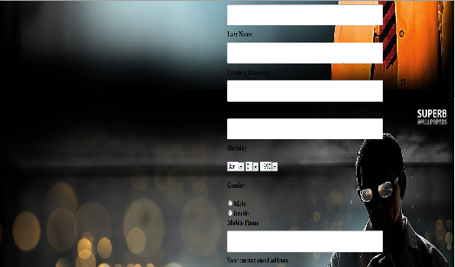
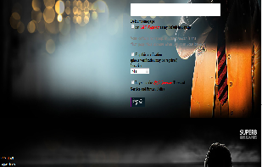

- LOGIN FORM

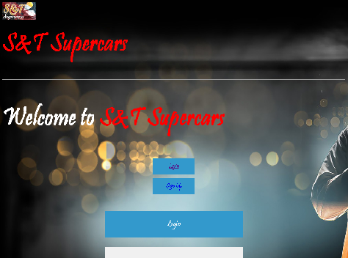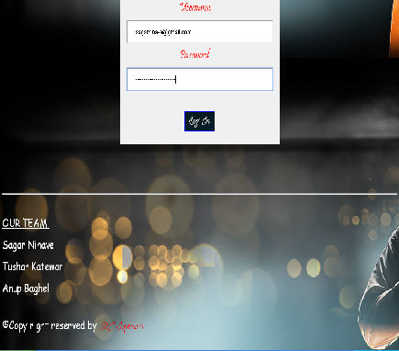

c) HOME PAGE

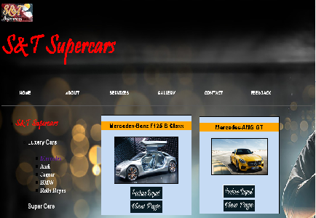
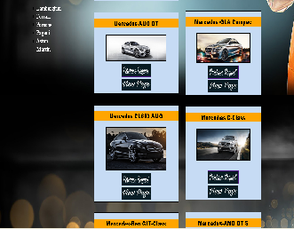
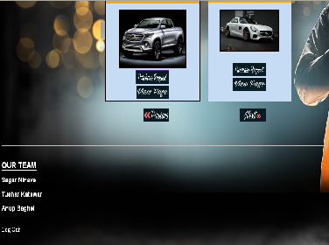
d) ABOUT PAGE

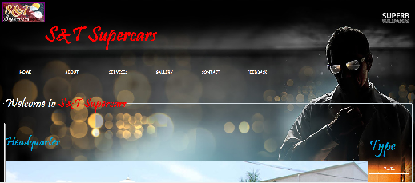
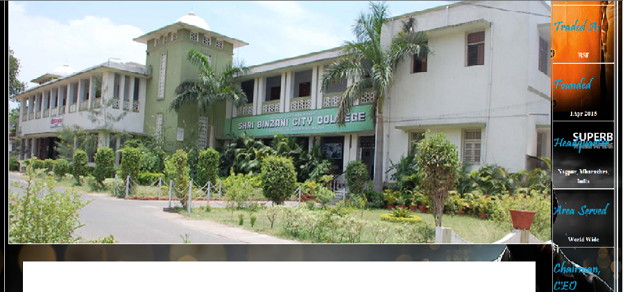
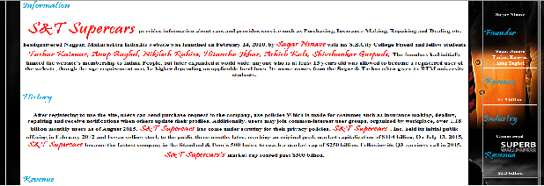
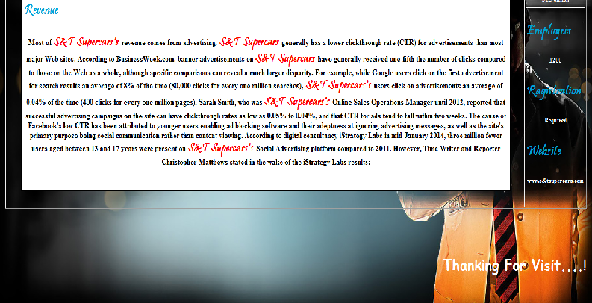
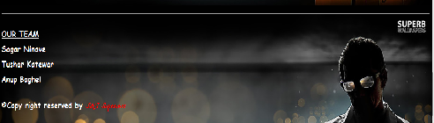

- SERVICES PAGE

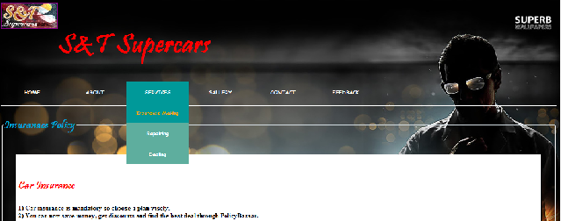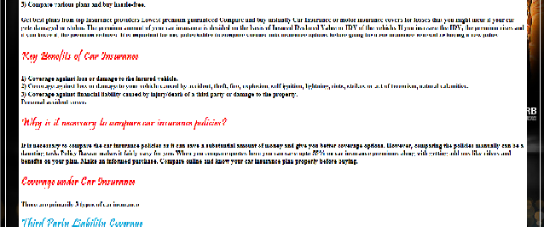
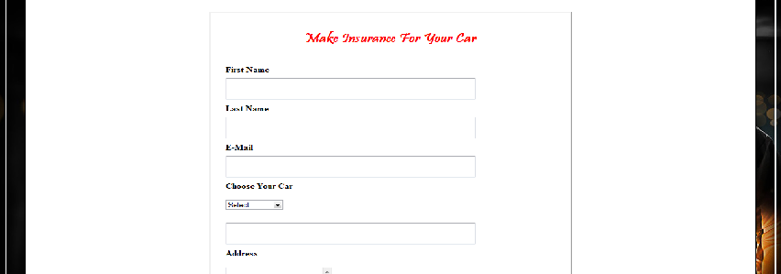
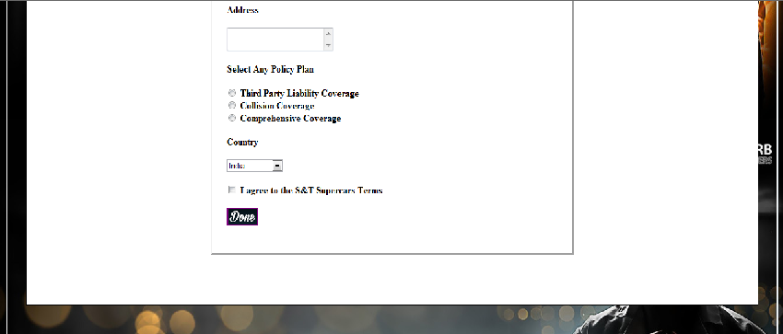
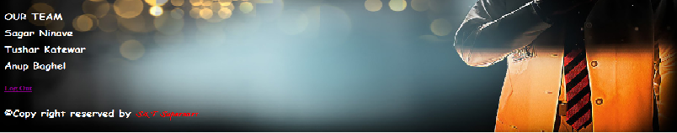

- GALLERY PAGE

g) CONTACT PAGE

h) FEEDBACK PAGE

10) CONCLUSION

This project provides a well computerized website “ S&T Supercars” This Is Very helpful for keeping the finding details, policies, information.
We have tries provide all the information about the luxury cars and super cars. Through this project we can feel the importance of S&T Supercars As well as luxury cars and super cars

11) FUTURE SCOPE

We are developing a website is view of social media. It will be able to get update from Consumer about cars, policies etc..People will be able to discuss about cars and policies with a people on website Using massaging feature
Our project also has other facilities that make it easy to use and implement in the day-to-day life. Furthermore, this project is user-friendly and full of GUI. So that, a person who is an
End-user in computer world can also easily through this project.
It is made in keeping all above said in mind. That it will acquire the future scope of it.
This project will show that which type of vehicle has maximum sale so that seller can take correct action about sale. Calculation of installment with interest is very easy in this project and information about any customer can be seen any time.

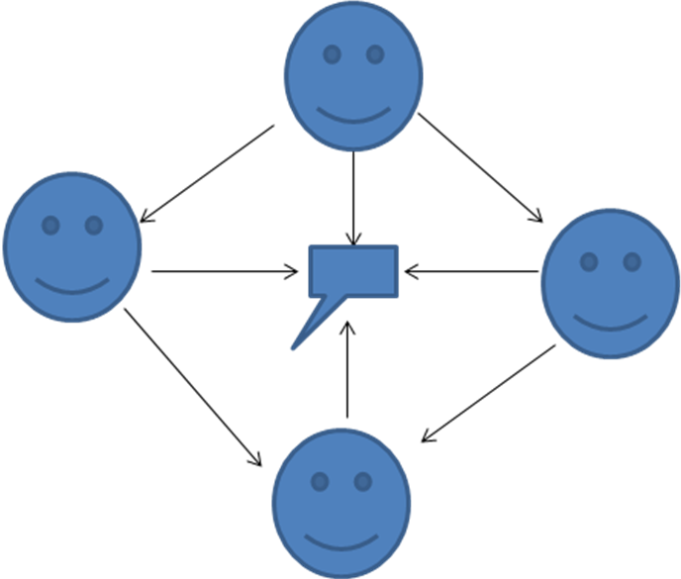

BIBLIOGRAPHY

1] WEB BROWSER

3] MS-ACCESS2000
Celeste Robinson

